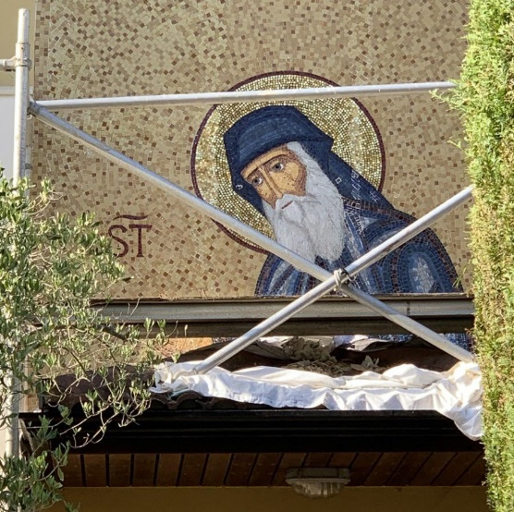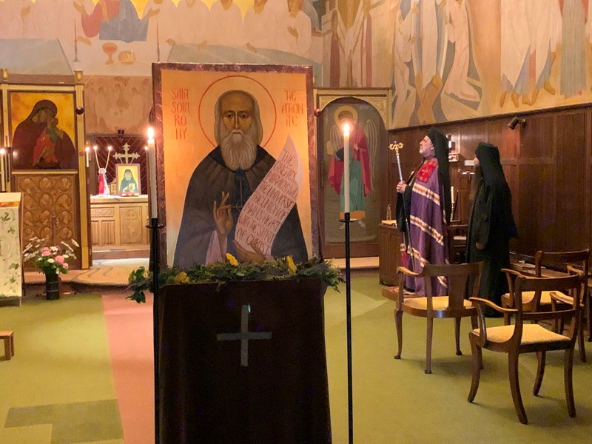

TALK BY SISTER MAGDALEN
OF THE MONASTERY OF ST JOHN THE BAPTST in Tolleshunt Knights, Essex
TO THE FRIENDS OF MOUNT ATHOS
6th September 2021 at 6 PM via Zoom

Many members who have visited the Monastery of St John the Baptist will have met or heard Sister Magdalen, who joined the monastery in 1977.
Sister Magdalen will talk about St Sophrony the Athonite, who founded the monastery, and who was recently canonized. She will discuss the importance of the Holy Mountain in his life and teaching. There will be an opportunity to ask questions afterwards.
If you wish to register for this talk, please contact Dr Maria Harff on foma.accadm@gmail.com .

Peter Lea
Hon. Secretary

